Citizens Assemblies For Future of Europe Conference
Author | Tony Czarnecki
Date | 2021-05-07 21:40:59
This presentation is the input of Sustensis to a debate on the subject Citizens Assemblies in the context of the Future of Europe Conference that started on 9th May 2021..
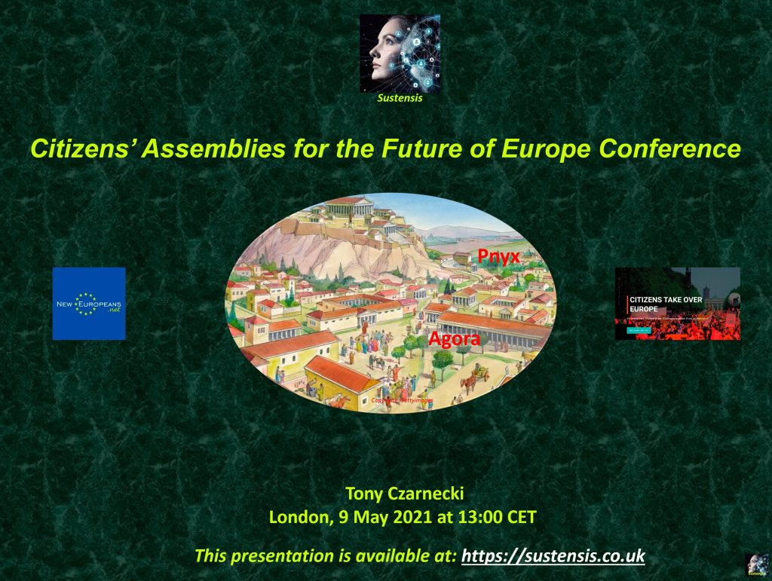
You can download the presentation by clicking here:

