Conference on the European Democracy
Author | Tony Czarnecki
Date | 2020-03-05 20:08:30
SUSTENSIS co-organized a unique event
On 2nd March 2020, Sustensis organised in co-operation with the New Europeans and The Federal Trust an event at the Europe House – the headoffice of the EU Delegation in London on the subject of the European Democracy. As part of that event, the participants were introduced to the Politics of Consensus – Repositioning the impact of Arts in Society – a unique approach created by Miha Pogačnik – a renowned international vilionist and the Ambassador of Culture of the Republic of Slovenia.
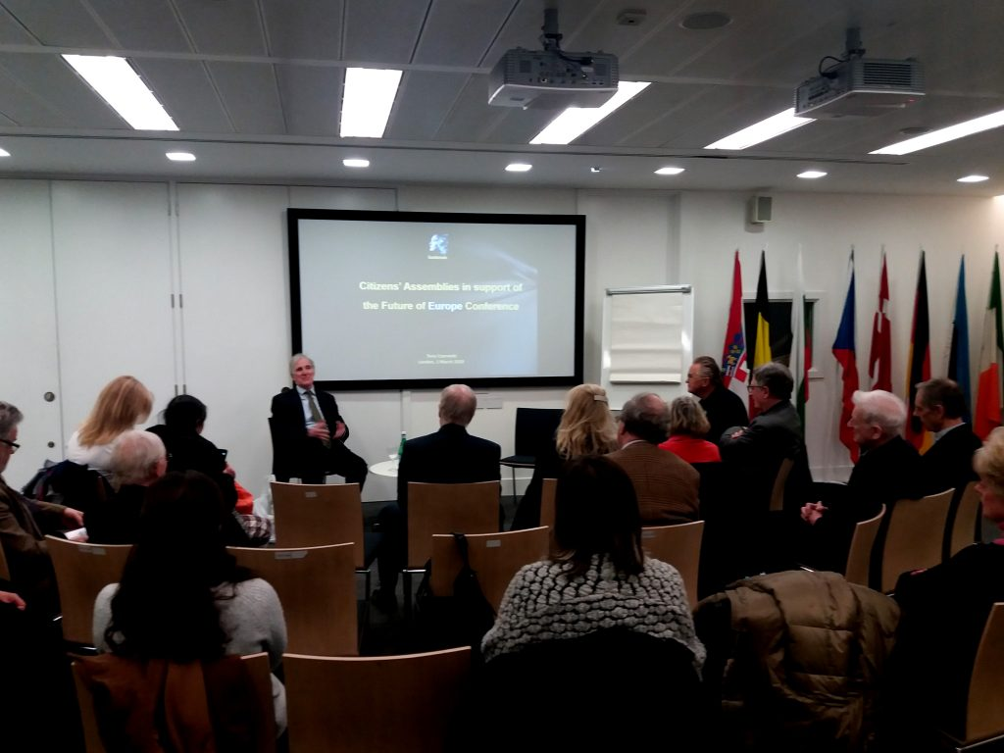
Conference on the European Democracy at Europe House, London
If you want to watch the video from the Conference then please click the relevant link below. You need to download the video, by clicking on the downward arrow in the upper left corner of the server, to get the original quality:
- An introduction to the Conference on the European Democracy - Brendan Donnelly - Director of the Federal Trust
- Citizens’ Assemblies in support of the Future of Europe Conference - Tony Czarnecki - Managing Partner, Sustensis
- Politics of Consensus – Repositioning the impact of Arts in Society - Miha Pogacnik, Ambasador of Culture of the Republic of Slovenia, which also includes an address by the Slovenian Ambassador to the UK - HE Tadej Rupel

