Global Disorder
Author | Tony Czarnecki
Date | 2020-01-17 20:38:46
I call the risks, which may become existential because of combinatorial effects (from days to decades) Global Disorder risks. They are linked to three domains:
- Economic Disorder, created by the economic instability and a disconnection between the real economy and wealth creation that has led to the crisis of capitalism
- Social Disorder, created mainly by the unresolved problem of social inequality and wealth distribution, intolerance and the impact of accelerating change, for which societies are totally unprepared
- Political Disorder, which is created primarily because of the crisis of democracy and the absence of a credible global organization that could act as a kind of the World Government, being an arbiter in political and military conflicts
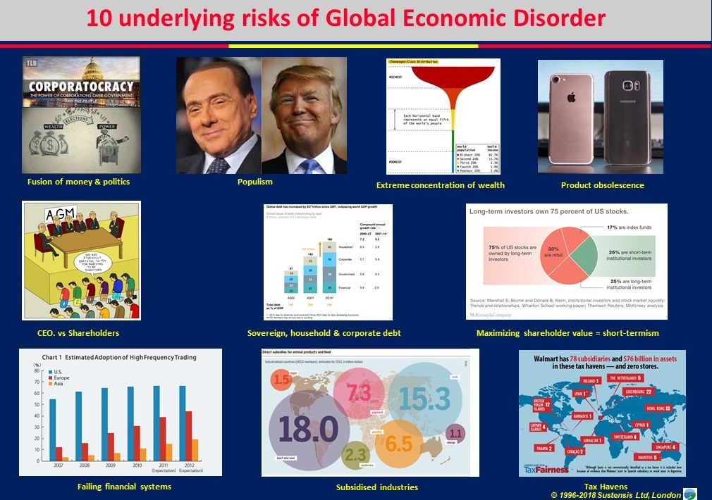
Global Disorder risks are not existential on their own and generally evolve gradually. However, because of their complexity and interconnection with other risks they may become existential through their combinatorial effects, i.e. if they are triggered off at the same time with other risks, about which we may not be even aware today. In most general terms, this category covers mismanagement of global affairs so serious that it may become the primary cause of our civilization’s collapse. This includes global migration on unprecedented scale caused for example by prolonged draught in Africa, ensuing famine and civil wars. Europe has already experienced a very mild migration of that kind in 2015-2016. But global socio-political disorder may actually be more acute in the northern hemisphere, in the more advanced part of our civilization, for different reasons than famine. The origins of the social unrest will be in the collapse of the basic structures that underpin the western civilization, such as democracy, capitalism, the concepts of freedom, equality and responsibility, the ultimate fall of religion and the associated values. This may lead to economic and societal collapse, involving civil unrest and a breakdown of law and order that might make the continuation of civilised life impossible anywhere on Earth.

