3. Reforming Democracy
Author | Tony Czarnecki
Date | 2020-04-13 20:42:03
You may wonder, what the reform of democracy has to do with a human evolution. And indeed, the connection is not obvious because it is indirect. If one accepts that the threat posed by Superintelligence is very real and could in a few decades lead to the human species’ extinction then, as explained in the previous subsection, one of the key risk limitation attributes are the values, which determine human actions and preferences. As it happens, values also underpin any system of governance, including democracy. Therefore, if one wants to make a deep reform of democracy, then the starting point must be a deep revision of our values in the existing Charters of Human Rights, such as the UN Declaration of Human Rights and the European Convention on Human Rights, signed up by 47 European Countries. Such documents should be used as a basis for the Universal Values of Humanity, on which a new Charter of Human Rights and Responsibilities could be built.
The prime use for these new values, which should be agreed by the majority of the states, although it is unlikely they would be agreed by all states, will be in the development and ‘education’ of the maturing AI. Equally important will be the use of the new values as the foundation for the reform of democracy, resulting in the revision of the states’ constitutions. Such constitutions should cover new forms of government, consensus politics and the creation of Citizen’s Assemblies, as one of the key differentiators in taking main political decisions in the future.
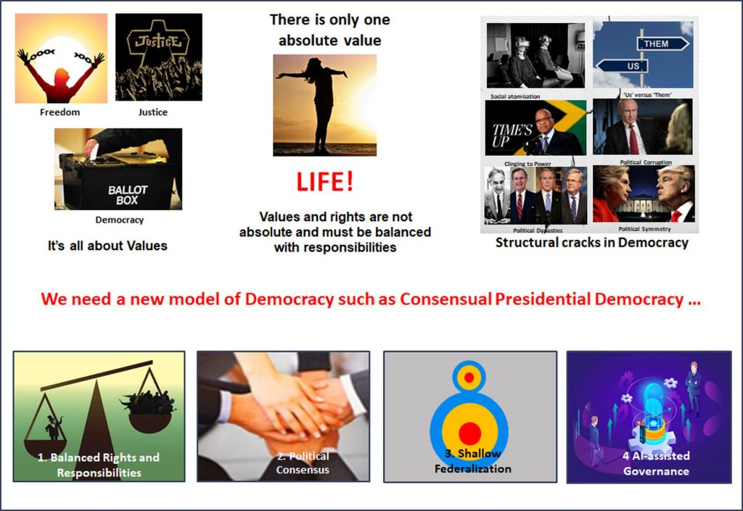
Reform Democracy
I have covered the subject of the reform of democracy in my previous book: Democracy for a Human Federation. There is also a detailed coverage of democratic reforms on this website here. Therefore, here I would only like to share some conclusions in the context of the Roadmap for a human evolution.
To retain a full control over the entire process of AI development, we must teach and instil in AI the best human values and preferences until its mature form – Superintelligence – becomes a single entity, millions of times more intelligent than humans and yet remaining our partner. We must agree as soon as possible what kind of democracy would be the most suitable for the transition period to coexisting with a mature Superintelligence. Once we reach that stage, democracy and the system of Universal Values of Humanity will have to be re-examined again since this will be the ethics and the system of governance that we will pass on to the evolving Humanity, as it will gradually be morphing with Superintelligence.
Tony Czarnecki, Sustensis
April 2020

