The Final decade?
Author | Tony Czarnecki
Date | 2020-07-19 15:13:00
This is probably the worst time for any futurist to make predictions. The main reason why it is so difficult to predict even the near future is that the scope, multi-dimensionality, and foremost, the pace of change is becoming almost seamlessly exponential rather than linear, which for a human mind is an unknown and a deeply disturbing experience. Perhaps one of the best examples of completely wrong scenarios for the future is the Francis Fukuyama’s prediction of ‘The End of History’ in the early 90’ – a super optimistic view of the new set of benevolent relationships that were to evolve between the superpowers, in the post cold war period. How wrong he was! Therefore, ‘The final decade’ may not be that final after all. And yet, forewarned is forearmed and perhaps presenting the near future in a somewhat uncomfortable way may contribute to selecting most pragmatic solutions to carry us through this turbulent decade.
We can look into the future from two perspectives. The first one, most common, is to project our current experiences and the state we are in, taking the average pace of change in the preceding decades and centuries as a measuring stick, and assess in that way the probability of the future situation materializing. The other perspective is to visualise what the future may be in a decade or two, and then return to where we are now, assessing the probabilities of various scenarios. This is how I prefer to view the near future, ‘the final decade’, ending in 2030.
Here, you may rightly ask, what does the word ‘final’ really mean and why it is this decade that is to be final. In my view, this may be the final decade for humans when we can still control the way we want to live our lives, and ultimately how we want to evolve as a species. You can search renowned sources on the Internet to make your own judgement if the word ‘final’ is an exaggeration. But I will only use two key points, which in my view justify this assessment.
The first point is Climate change, when many, if not most, of the scientists agree that the tipping point of the global temperature increase will be reached by 2030, if sufficient measures have not been implemented by then. Failing to deal with climate change properly will determine to a large degree the quality of our lives. Directly we may initially only feel discomfort, but gradually the climate change will become life threatening. Indirectly, and much sooner, it may turn into a powerful trigger for other existential risks, such as massive migration, wars or pandemic, all leading to a global destabilization of political, military, economic and social balance. It is already too late for the current actions, including an imaginative EU’s climate change budget, to halt the temperature increase by 2030. The only feasible way might be to start an urgent geo-engineering reset of the planet’s climate, using temporarily the least environmentally damaging measures (and there are over 100 of them). So, we still have some control over climate change till the end of this decade. If we fail, the planet may become uninhabitable for humans by the end of this century.
The second one, much more difficult, is the threat of the AI development, which is also likely to be out of our control by 2030. To avoid any confusion, I am not talking about millions of robots taking over but rather a subtle, web-like self-learning, single entity, grown out of the current multitude of AI projects. If such an entity becomes malicious, then we may only have a few decades left before humans become extinct or enslaved. We can no longer stop that process, like we cannot uninvent a nuclear bomb. More importantly, whatever type of AI we will create, even if it becomes our friendly partner, we will be gradually handing over more and more control to it. Climate change, at least initially, will impact the quality of our lives. AI has been already impacting the decisions we make. Within this decade, we will be rubber-stamping at a personal and governmental level most of the decisions taken by an AI agent on the basis of a previously given consent. Today, we think we understand the consequences of these decisions, for which we have given a prior consent, and more importantly, we trust, that our smart phone that already embeds a lot of AI technology, is not outsmarting us for its own, potentially devious, hidden aims. But for how long will we be able to trust these agents, which already have some emotional features built in?
I realize it may be hard to accept such a dystopian view at this point because these scenarios are not on the front covers of our daily papers, at least not yet. However, let us assume that this is indeed the last decade when we can control our future. How do we see the current developments on the global political stage, the pace and breadth of actions taken, and the significance of the proposed solutions matching the above challenges? Wouldn’t you agree that if this is our ‘final hour’, and if so, the actions of politicians of large and small countries, including the UN, are just incredibly insufficient? What actions then may be taken, or rather should be taken. I will start with the most desirable solutions from a global perspective, before I come to the UK’s courtyard.
We cannot solve global problems, which can now be rehashed as Humanity’s problems, locally. They can only be solved globally. In order to do that, we need a global organisation with the powers of a federation, on par with the powers of the US government. We face two problems here. First of all, there is no way that such an organization can be created from scratch and achieve the desired effects in such a short time (e.g. reduction in a global temperature or having a global control over AI development). Therefore, it has to be an existing organisation, which would very quickly embrace not just its current members but also the majority of the countries on the planet. Realistically, there are only two organisations that might fulfil this role – NATO or the European Union. For various reasons, mainly the lack of diverse experience, NATO seems to be a less suitable organisation. So, the only remaining candidate is the European Union. However, there may also be a kind of the last resort candidate – China, with all the unwanted consequences.
If we assume, that the EU would take this role, it will of course have to become a federation and very quickly expand by including more and more countries (I leave aside a big potential problem that the EU may not want to do it). To play the role of the ‘saviour of Humanity’, the EU will not have to include all countries by 2030. It will be sufficient if it creates a critical mass, where its decisions will by default have to be implemented by most countries (the only current threat is banning the access to the EU market). That is what has happened with GDPR, which formally applies only to the EU, but actually is adhered to by the vast majority of the countries. There are also some very positive developments in the control of AI, with some EU’s legislation to be ratified by the end of this year. However, such a legislation requires literary a global control of AI and not just within the EU. In any case, the EU would have to become a de facto World Government by the end of this decade.
Now let us look what is actually happening in the EU and what are the latest initiatives in the area of EU integration (a codename for a federation). Many of the top EU politicians, like the German Chancellor Angela Merkel, heading the EU’s Presidency right now, or the former President of the EU Council, Donald Tusk, have an idealistic objective of achieving ‘an ever-closer union’, i.e. federalization of the entire EU in one stage, even if it happens at a slow speed. They point out on the difference in the GDP level per capita, which for the top countries, such as Austria, Belgium or Germany is about 5 to 6 times higher than for the bottom ones, such as Bulgaria and Romania. They also say that waiting for another decade to start the preparation for the Federation, is a safer option because the currently poorer countries will make faster incremental improvements in their GDP and in the social area than the richer countries, making the differences between members states smaller, and the transition easier.
In my view, this should not be a preferred option and the whole EU should not be converted into a Federation at the same time. The main reason is that there will be new countries joining the EU, which will be less ready than the ‘old’ member states. Therefore, there may never be the right time for all the EU countries to federate together. Waiting a decade or more will be very risky indeed, see above. But on top of that, we now have a Covid19 pandemic, the effects of which may last throughout most of this decade. There are also, of course, all the ‘classical’ risks stemming from the increasing level of the world’s instability, e.g. the continuous meddling of Russia into the EU affairs and the volatility of the financial markets. The further the moment of the federation is pushed back, the higher the risk.
The EU Commission has an unapproved scenario 6 (courtesy of Mr Juncker), which envisages that EU should transform itself into the European Federation by 2025. Not so long ago it looked very unrealistic. But after Covid-19 pandemics, it will be a necessity. The post-pandemic economic and social crisis has already engulfed the EU, as it has the whole world. The ensuing chaos will be multi-dimensional including high permanent unemployment, caused by an earlier arrival of Technological Unemployment, significant drop in the GDP and social unrest. But there will be other areas that may simultaneously aggravate the super crisis, such as a pension crisis, or the rise of interest rates. Finally, there could also be other momentous events linked again to a sudden migration e.g. from the Ukraine, if it falls apart due to another coup d’état. This might lead to sealing off the internal EU border, the collapse of the Schengen zone and prompting some countries to exit the EU in a completely chaotic way. That could spark off the break-up of the EU into several groups such as the original six founding members, the Visegrad Group, or the Scandinavian countries, which might re-join EFTA, where they were before.
To avoid that, the ‘core’ EU countries may be forced to start a quick fix, untidy, untested variant of the EU federalization, as a risk mitigation strategy. Germany might then see the creation of a Federation as a safer option both for Germany and Europe. Through the European Federation Government, it could take full control of the budget and thus reduce its potential losses. Therefore, crises like these may paradoxically be a trigger for a much faster federalization of the EU. This envisages a transition to a rudimentary federation, when only the most necessary functions would be federated, such as defence, security, foreign affairs, and the common currency. This is now, in my view, the most likely outcome.
Should such events happen in the next 2 years, then it could be president Macron, rather than Mrs Merkel, who might be the standard bearer for the EU federalization, almost exactly 200 years after Napoleon tried to do just that. What a perspective! In such a scenario, Italy might remain on the side-lines and play a less prominent role in the future federated EU, replaced by smaller but economically stronger countries such as Benelux, Ireland and Sweden.
Whatever triggers the process of a Fast Track Federalization, the initiators may invoke Article 20 of the Lisbon Treaty. Like the article 50, which facilitated Brexit, it is ‘the article of the last resort’ or a kind of a ‘nuclear option’. That is why it is perhaps least known, because it has never been used. Additionally, it is one of the most complex and convoluted articles in the Lisbon Treaty, probably done in this way to hide the real intention of the proposers, since this is the gateway to a federated Europe. Therefore, I spare you the full wording of that article. In plain language it means that if at least 9 members of the EU want to federate, they can practically do it at any time. The post Covid-19 economic, social and political upheavals may create unprecedented tensions within the EU. Therefore, if we include personal ambitions of some politicians, and deep structural budgetary problems of the Mediterranean countries (Greece, Italy, Spain, and even France), it may happen indeed within a few years.
There are of course other ways of achieving the Fast Track EU Federalization, which may even include countries currently outside the EU, namely the EFTA members – Norway, Switzerland, Iceland and Liechtenstein. Paradoxically, if the level of federalization is very shallow (which I think it should be), it might also become, at some stage, a face-saving solution for the UK. The main problem here would be the need for the UK to accept the European Court of Justice, and later on, the European Constitutional Court, as the supreme legislator. However, we live in such abnormal times that anything is possible. In this context, even the most advanced version of the proposed Conference on the Future of Europe, put forward by the EU Parliament, looks very uninspiring indeed.
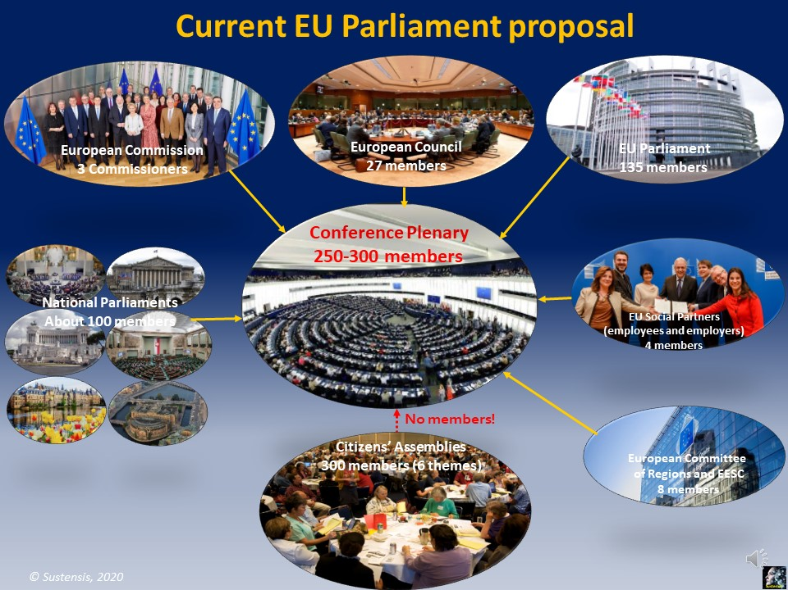
The Conference is to discuss six subject areas (called Themes): Institutions, Economy, Security and Defence, Climate Change, Digital World and Social Issues. Each of these themes is to be deliberated in one of the six chosen EU countries at a series of debates at Citizens Assemblies over a 2-year period. The decision-making body is to be the Conference Plenary, but the European Council does not want these decisions to be binding and has not agreed to allow any members of the Citizens’ Assemblies to take part and have a vote in the decisions made by the Plenary.
It is not yet known either, if this fresh attempt will fundamentally change how the EU works. Before the Covid-19 pandemic it was clear that a strong opposition would come from the usual suspects. These are the EU leaders – members of the European Council, because they would lose most, should the Conference end with a success, like the creation of the European Federation. However, what is encouraging, is a strong support coming from the members of the European Parliament.
Since the situation after the end of the current pandemic will be entirely different than just a few months ago, people supporting the European federalization, such as nearly a hundred federalist movements, should press for abandoning the current minimalistic goals. Instead the Conference agenda should be bolder and include the debates on the shape of the future European Federation, calling for a Constitutional Convention and setting a concrete date for the transfer of those EU members that want it, to the European Federation. They should thus use the momentum and the infrastructure of the Conference (with some modifications) but reject the proposed objectives as far inadequate from what is required right now. Instead, they should take Presidents Macron’s call for giving more power to the EU Citizens literally. After all, if a representational democracy has failed so badly to meet the expectations of the electorate, the electorate itself must insist on formulating their demands in a direct form, e.g. through a network of Citizens’ Assemblies.
The Covid-19 pandemic may have created another paradox. This time it relates to the United Kingdom. The changes on the British political stage have accelerated rapidly, although not necessarily in the right direction. What can be clearly seen from nearly a year of Boris Johnson’s government, is an unrelentless push for the centralisation of power. People hoped that dramatic scenes in the British Parliament during the process of Brexit ratification, including the legally questionable proroguing of the Parliament, would end. Just to the contrary, as the latest attempt to nominate Chris Grayling as the head of the Intelligence and Security Committee by the Government, rather than by the Committee itself, proves. More importantly almost a provocative continuous disregard for the Scottish Government to be consulted on post-Brexit options, may only widen the current cracks in the system of the United Kingdom governance opening a real prospect of the end of the Union.
So, what is that paradox. In this short scenario there are many variants and ‘ifs’. The first one is that the conservatives will have enough of Dominic Cummings and Boris Johnson. We can see an anti-ERG Group emerging in the Parliament, fuelled by Theresa May’s bitter fight with Boris Johnson and also some dislike of his centrist policies by a growing number of Conservative MPs. That may lead to an election of a new leader, such as Rishi Sunak, even before the post-Brexit deal is ratified. If it happens next year, which is more likely, Britain, Europe and the world will be in the midst of a real mega crisis, which when combined with the post-Brexit chaos may lead to a rapid resetting of the British political stage. This may include such momentous events such as: forming a government of national unity, avoiding the Scottish departure from the UK by having a Constitutional Convention, which will create a new British Federation.
Finally, this turbulent period may open a sudden opportunity for a quick re-entry to the EU, perhaps by participating in the Conference on the Future of Europe. This might allow Britain (again paradoxically) to have a significant say on the shape of the future European Federation, reflecting more the British view and indirectly justify Brexit a posteriori. This would mean creating a Federation, as a Minimal State, a miniFed, with only the most important areas being federated, such as defence, foreign affairs, the budget and the common currency but built on the shared set of values.
Whatever happens, I believe this may be the final decade when humans are still in control of their future. But that does not mean that the future must be dystopian. Just to the contrary, we are only perhaps less than two decades away from the world of abundance. The problem is that we must cross a weak bridge over a bulging river that separates us from the opposite shore. There is a price tag attached to enable us a safe passage, which requires the resetting of our values and the relationship between the nations, so that humans behave like bees in a hive.
Tony Czarnecki,17th July 2020

