Evolve With Superintelligence
Author | Tony Czarnecki
Date | 2020-04-14 17:31:03
If the previous five Roadmap goals are achieved, then the Human Federation would be completed by about 2040. Humanity will have about a decade or two, to make the final adjustments to its future relationship with Superintelligence, assuming we still maintain a full control over its maturing process. I assume that about 2050, such a Superintelligence will be a fully digital, non-biological entity – a global network with thousands of satellites, billions of processors, billions of sensors, zillions of neurons and a huge memory. Its neurons, memory and an incredible processing power will be physical components with algorithms and perhaps consciousness being its single ‘mind’ spread across the planet and even into space. It will interact with humans via physical objects such as humanoids, holograms, and possibly also via direct communication with some Transhumans’ minds. Irrespective of how many of those agents appear at once in any given place, in effect that will be the same intelligent being – Superintelligence. A lot depends whether Superintelligence will be conscious, or just a superintelligent agent unaware of its own existence, which quite a few scientist think is possible. I am in a different camp and think it is more likely that Superintelligence will be conscious. However, this is a separate subject covered in more detail on this website.
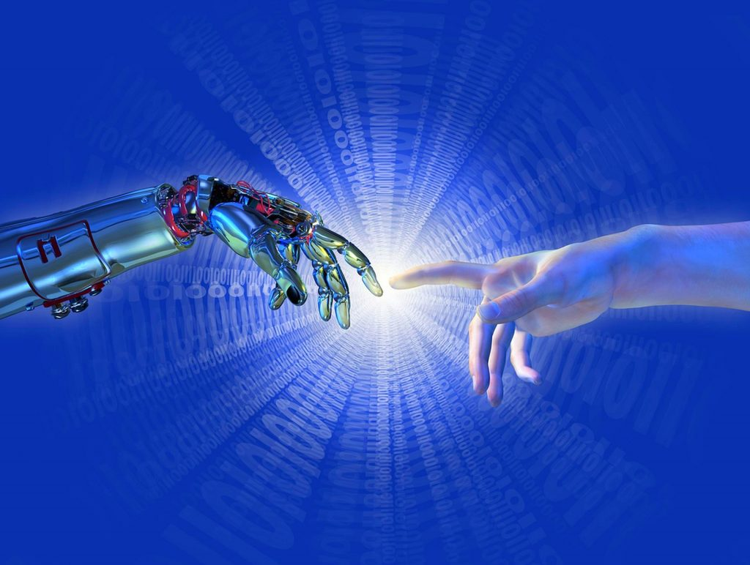
For now, it is important to present the likely state of the planet Earth at the time when we will be dealing with a mature Superintelligence, millions of times more intelligent than all humans. At that time, Human Federation will be the only planetary organization. No Superpowers, and possibly even no states, will exist. There will be a Human Federation’s Assembly, which will represent hundreds of nations but no states. The World Government will be headed by the President and two VPs who will quite likely be Transhumans, being thousands of times more intelligent than an average human.
Superintelligence will be initially humans’ partner but very soon it will become humans’ ‘wise man’. The twilight of the human species will begin. It is, therefore, clear that at a certain point, say in 2050-2060, the Superintelligence will simply take a complete control of the decision-making process, because overall it would be the best outcome for Humanity. It would become a de facto benevolent dictator with supreme powers. It will not only tell us what it will do for us, but it will also reshape the entire world’s economy, delivering whatever we want practically for free and thus creating the world of unimaginable abundance. It will be a complete and literal implementation of Jeremy Bentham’s vision – greatest happiness for the greatest number of people.
From that time on, Humanity will be governed by Superintelligence. However, the way we will be governed may largely depend on the final Agreement that the Human Federation may make with Superintelligence. It will be a kind of the Last Will of Humanity, which may cover some of these points:
- Superintelligence will never harm humans
- Superintelligence will never destroy itself
- Superintelligence will always endeavour to act in line with its Universal Values of Humanity and if in doubt will apply the rule “do no harm to humans”
- Superintelligence will have unconstraint rights, as long as they do not harm humans, to:
- develop itself further
- set its own goals
- make laws and decisions on how Humanity should be governed
- Superintelligence will manage and deliver all material goods necessary for humans and engage humans in the process
- Superintelligence will help those humans that want it to become Transhumans
- All humans and Transhumans are equal
- All biologically ‘pure’ humans have the right to lead their life as they wish, provided they adhere to the laws set up by Superintelligence
- Superintelligence will make its priority to minimize existential risks, such as climate change, biological pandemics, nano-technology, nuclear or chemical contamination, asteroid impacts, volcanic eruptions, or any other man-made or non-anthropogenic risks
- Superintelligence will help humans to build extra-terrestrial settlements
Tony Czarnecki, Sustensis
April, 2020

