Visualizing Superintelligence
Author | Tony Czarnecki
Date | 2020-01-17 09:26:09
Now, let us deal with the external ‘look’ of Superintelligence. Today, your computer, is just one of billions of nodes to Google. Similarly, in the future, Superintelligence will also have billions of nodes, through which it will be able to see, recognize and talk to anyone at once in any part of the planet. But most importantly, the collected knowledge and experience of living among humans will be available to each individual of these node, assuming such a node will have appropriate cognitive capabilities, as well as access rights. This process of gathering and accessing the collective knowledge is already happening. This is how Amazon operates when we purchase some goods, almost immediately proposing us new articles that we may have never thought about we might need.
Similarly, Alphabet’s (Google’s) Waymo – a driverless company, as well as Tesla, collect each car’s unusual ‘experience’ and the way the car reacts, and makes it available to all Waymo’s or Tesla’s cars. What has been already happening and expanding at a lightning speed is the creation of a Pool Intelligence. That is how Superintelligence will operate in the future as well. That Pool Intelligence will become its collective intelligence available to all licenced agents and nodes.
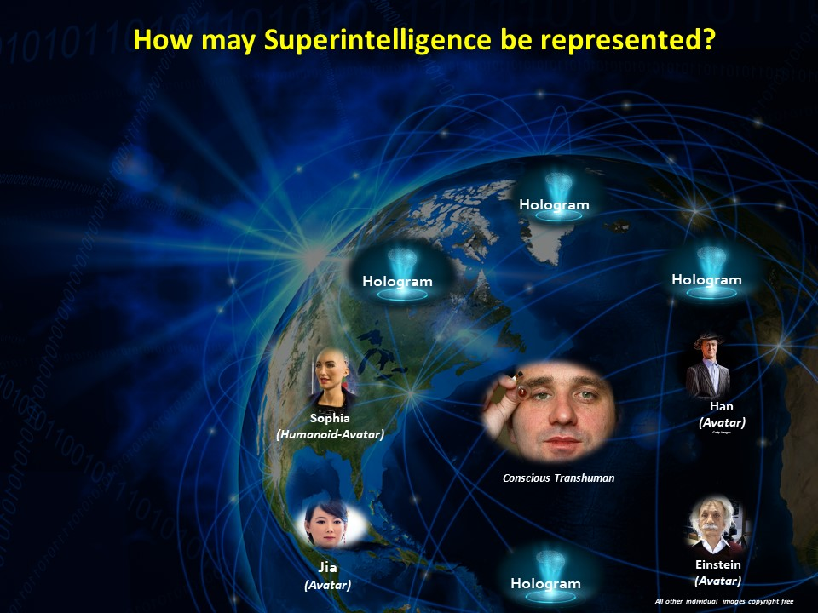
Not all nodes will have the same rights of access and decision making. Most of them will be passive like yours, or my computer, a driverless car, or a self-flying plane. They will be just for asking questions and interacting at the lowest level of access rights. That will probably be somewhat similar to how we operate Google’s search engine right now.
However, some of these purely digital nodes, very few, will have special access to the overall goal settings and decision-making on behalf of the entire Superintelligence. I call them Digital Governors. They will be similar to what it is today, when the top Google developers and managers decide what functions Google applications will have, how those functions will be executed, and how individual people will be able to use them, which may depend on the users' access rights. In that sense, these Google's AI scientists are a decision centre (the 'brain' of the Google browser).
It is hoped that those Digital Governors, representing Superintelligence, will be under the ultimate control of humans for as long as possible (those humans will most likely be Transhumans, authorized by the Human Federation as the World Governors retaining the decision-making under Humanity's control). We will perceive these very few, special Digital Governors as ‘The SUPERINTELLIGENCE’. They will become special by being selected at a certain time, (my best guess is between 2040-2050) and uploaded it with their overall goals, values and modifications.
These special nodes will have different representations depending on a situation. This may include Superintelligence being represented as humanoids in an artificial skin, with muscles, face etc, which you will not be able to differentiate from a human being. You only need to view some video clips on YouTube to see how difficult it may be even today to tell who is a human being and which is a robot. By being digital, they will be able to copy themselves and thus appear exactly the same in many parts of the planet, at the same time, as a personified Superintelligence. However, most likely they will be represented by holograms, enabling them to instantaneously create themselves and be in any part of the planet simultaneously, interacting with various audiences.
We will be able to communicate with Superintelligence represented as humanoids in a similar way as we communicate with other people and with some digital assistants such as Alexa or Siri. The communications between Superintelligence and humans will most probably depend on the level of authority a person would have.

