Top Existential Risks
Author | Tony Czarnecki
Date | 2020-01-20 16:29:10
Superintelligence is not the only man-made existential risk but it is, excluding laboratory originated pandemics, the earliest and the most severe. So, what are the other existential risks?
There are several organizations focused on identifying and reducing global catastrophic and existential risks such as Global Challenges Foundation, University of Oxford. They apply various methodologies for calculating existential risks, but none is failproof, nor is the data very rigid. Furthermore, not all risks are equal. They differ according to their impact and the probability of the risk materializing, which is calculated using the formula: Risk = Probability * Impact. Therefore, the risks calculated by various organizations or well-known specialists in this area vary significantly. For example, in 2008 the Future of Humanity Institute carried out a survey of the academics gathered at a conference discussing global existential risks and the likelihood of the most significant anthropogenic risks. They estimated that the combined risk of human extinction this century is 19%. That means, by the end of this century there is at least 19% chance that one, or several existential risks in the table below may materialize with the worst impact scenario - the end of the human species. In the period under consideration on this website, say over the next generation, such probability is about 5%. These are only the risks over which we have some control, mainly in political, military and social domains, such as nuclear wars, or artificial pandemics.
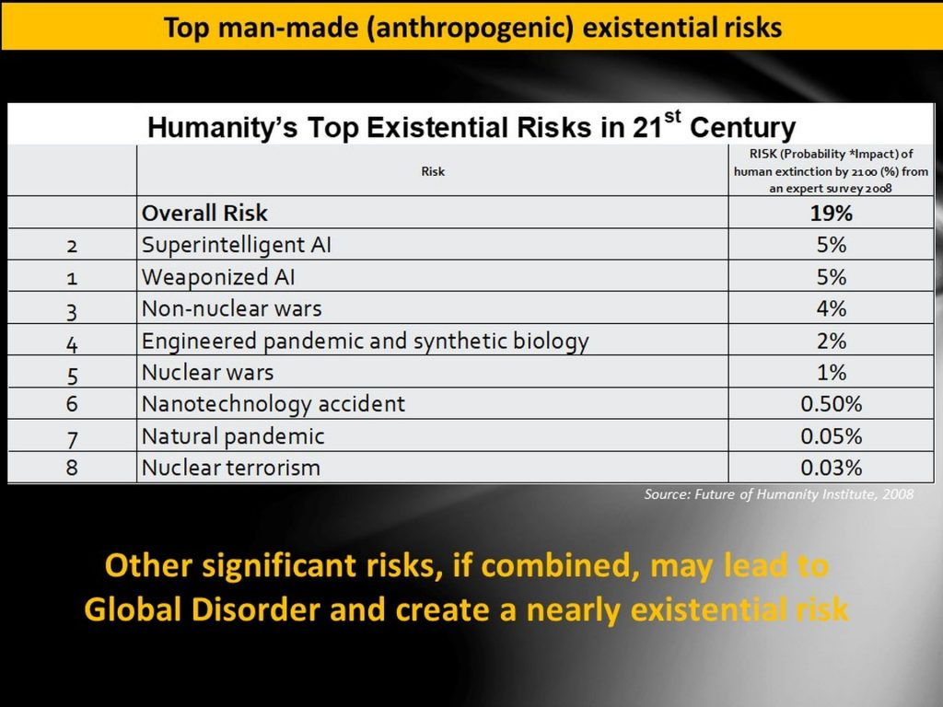
Assessing such risks is very difficult because of the interconnections (convergence) between them. Therefore, these numbers have to be really considered as indicative and prone to significant errors, mainly because of lack of hard data or insufficient understanding of the impact and the spread of a specific risk. The risks listed in the table may be very conservative indeed, as they do not even include the global warming, which an influential Stern Review on the Economics of Climate Change calculates as 0.1% per year, leading to the likelihood of human extinction over a century to nearly 10%.
I cover these risks in more details in the subsequent sub-menus.

