European Federation State
Author | Tony Czarnecki
Date | 2018-05-01 13:00:41
This is an extract from Tony Czarnecki’s book: ‘Democracy for a Human Federation’
The arguments provided so far, confirm that the EU transition into the European Federation (EF) should not happen in one stage, nor the EF should become a single zone organization. The only realistic way forward seems to be the creation of some Transition Zones, which would allow member-states to move to the next Zone up at their own speed, ultimately joining the European Federation State. Doing it piecemeal is, in my view, also the best way forward because the federation will show other countries outside that zone how it works in practice. This is the process broadly supported by President Macron and Jean-Claude Juncker, the President of the EU Commission. There is also an additional argument for a multi-speed, multi-zone EU. Namely, the transition of the whole EU in one stage in the next few years may increase the recent ‘awakening of the national spirit’ in some countries that border on nationalism, as can be evidently seen even in countries such as France. Therefore, such a proposal would have been at this moment badly received by the population of most EU countries and lead to even stronger anti-European Union sentiments.
Taking all this into account, the transition of the member states into the EF after it has been established as a single state, should be a continuous process of members migrating from a lower zone to a higher zone until they are ready to pass their sovereignty rights to the EF. However, the question is what should be the relationship between the EF State and the member states of other zones.
I have reviewed several options to see how many zones the future EF would need and what should be the criteria for each zone. The zones differ between each other mainly by a degree of limitation of the members’ national sovereignty that they may have to give up on behalf of the EF. These could be, for example, the control the EF would have over the members’ policies. This might relate to common foreign policy or setting up national budgets. These are, of course, my assumptions. The reality will certainly be different. Let’s review the available options regarding the relationships between the EF state and the member states in transition zones.
- The EF state becomes a separate entity from the rest of the EU. I would exclude this option straight away for two reasons. Firstly, the control of the future development of the non-participating EU members (currently 8, assuming all Eurozone members would join) by a more mature EF state might be limited. Secondly, the ‘stranded’ member states might simply disperse, some of them joining the EF and some becoming totally independent states. That would be, at least at a psychological level, pretty bad. Therefore, I discard the option that the EF becomes a separate ‘member state’ from the rest of the EU.
- The EF state is formed in one stage from all members of the Eurozone and at the same time the remaining 8 EU member states become part of the EF as members of one transition zone, let’s call it the European Federation Convergence Area (EFCA). In this option, all Eurozone members make a transition into the EF at the same time. The EFCA members would join the EF at their own time when they meet all the required conditions. That would make the EFCA a subsidiary of the EF state. This option would not work because it is not future-proof, and leaves no formal structures for accepting new members, when all of the current non-Eurozone members will have joined the EF. But even if such a zone would have been allowed to accept new members, it will be less flexible, because it is a key element of the future convergence into the Human Federation, which should allow further rapid expansion, while retaining a high degree of integrity. Therefore, the EF state should not be formed in one stage with one transition zone only.
- The current Eurozone members are federated as a single state with several zones as its subsidiaries. That would mean that the current remaining member states of the EU form the European Federation Convergence Area (EFCA) as the EF subsidiary Zone 1. Additionally, other zones might be created in a similar way to facilitate greater flexibility for EF expansion. This would make the relationship between the EF state and its subsidiary zones similar to the United Nations and its subsidiary organizations such as UNDP or UNESCO. Therefore, I would consider it as the chosen solution for the EF setup and propose that the European Federation state with four subsidiary zones:
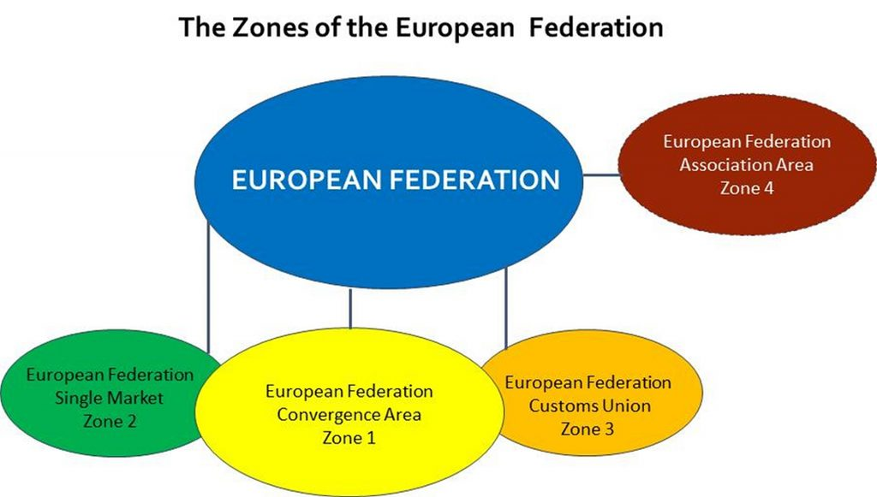
Zone 1 is a member of both Single Market and Customs Unions. Members who are both in the Single Market (Zone 2) and Customs Union (Zone 3) do not necessarily have to move into Zone 1. Some members in Zone 4 could also be members of Zone 3 (Customs Union), like Turkey is now.

