Options for the EU Transition into a Federation
Author | Tony Czarnecki
Date | 2018-05-01 08:53:23
This is an extract from Tony Czarnecki’s book: ‘Democracy for a Human Federation’
The most imminent, and one of the biggest risks for Humanity, is that our civilisation will just keep going on until the point, beyond which saving humans might be a futile effort. To change the course of civilisation so that it progresses as a uniform global entity would require the World Government. However, a rational discussion among world leaders, say within the UN, on forming such an organisation like the World Government would have been rather unthinkable and utterly unrealistic. That’s why I believe the only feasible option that could become operational relatively quickly it to select an existing organisation. In my book I have done the analysis of 10 potential organisations and large countries which might act on behalf of the whole Humanity. The outcome of that analysis was that the organisation best suited for such a role appears to be the European Union (EU). It has the greatest potential to be transformed first into a federation and at some stage starting to act as a de facto World Government.
For the EU to transform itself into a federation is an existential necessity anyway. Its member states must complete such a transition into a federated state, let's call it the European Federation (EF), within a decade. Otherwise, the EU’s inherent inconsistencies and inflexibilities originating from significant economic, social and cultural differences (even within the same Christian culture) will gradually rapture its structure leading to its disintegration. That could start a period of political instability, which would almost inevitably be exploited by Russia, leading to European wars with most disastrous consequences.
To be successful, the creation of the European Federation must be done in such a way that the new state will guarantee the former nations maximum flexibility and the widest possible scope for self-governance, i.e. that most decisions will be taken at the lowest possible level of governance. This would minimize the tensions stemming from cultural and social differences. The only way to do it could be through the process, which I call “cantonization of Europe”. That is a reference to the way Switzerland has been governed for the last 200 years, giving maximum level of self-governance to each of its 26 cantons. That would effectively lead to the creation of the European Federation composed of former EU states, but in which some of the larger regions (say over 5m population) would have an automatic right to statehood, either on their own, or by merging with neighbouring regions of other states.
The existing Lisbon Treaty could almost certainly be used as a starting point to either making significant amendments to that Treaty or becoming the input for writing an entirely new EU Constitution, which may require the creation of the Constitutional Convention, as was the case with the unratified Constitution of 2004. The most important impact of these proposed changes to the current Lisbon Treaty would be for the member states giving up part of their sovereignty to the EF.
The other objective for the new organisation should be to address the existential risks facing Humanity. It would thus have to stand up not just for the people of Europe, but at some stage also for the whole Humanity, in the absence of a credible organization that would have ideally included all nations. The main benefit would be the increased safety of all of us, and in the long-term - a more humane and just civilization.
Existential risks force us to take extraordinary steps to save human species from extinction. Artificial Intelligence is one of the biggest risks. However, at the same time, it could still help us to make a transition to the new époque of humans and Superintelligence co-existence, by re-designing and implementing the new world order. Since we have very limited time, possibly less than 20 years, we must rely on the best organizational, technological and material solutions that we already have. The most feasible way forward is to entrust the fate of Humanity to a widely reformed and federated European Union. Therefore, from that point of view alone the future European Federation must:
- Become a credible and effective organisation that will be able to mitigate all man-made existential risks
- Ensure global political, economic and social order necessary to focus all efforts on our survival, since lack of a reasonable global stability may become, through combinatorial effects, an existential risk on its own
- Endeavour, to preserve what is best in Humanity as a kind of a treasure chest that at some stage might be passed to Superintelligence – our values, rights, and intellectual and cultural assets, to avoid the emergence of a valueless Superintelligence, or equipped with dangerous values and objectives that in the end could destroy us all.
But then we must also look from a narrower, European perspective. Over the last 60 years of its existence, EU has managed to achieve something unprecedented in the European history – peace, continuous economic growth and relative social order. That pedigree and experience has probably tilted the odds for selecting the EU as the best candidate for expanding its role, and after its gradual transformation into the European Federation, serve wider aims, than just purely European objectives.
Irrespective of a particular route that the EU takes, or is forced to take towards federalization (e.g. at the time of a super crisis), it should announce within a year some immediate interim measures. There are, in my view, at least three such commitments that should be made by the Council of Europe within the promised Future of Europe Conference probably to commence in the autumn 2020:
- The EU will start preparing a new Constitution, which should be ready within a few years, by establishing a Constitutional Convention. Most EU leaders would definitely prefer to plough on and preserve the status quo. This may change, under the pressure mainly from President Emanuel Macron. A new type of socio-political bodies, Citizens' Assemblies, discussed already on this site, which are part of the Conference, will take every opportunity to take the subject of Treaty change (a codename for a new Constitution) vigorously.
- The strategic direction of the EU is an ever-closer union that may ultimately lead to the EU becoming a Federation at some point in the future. The EU leaders prefer to delay that moment as much as they can. However, the EU needs to be prepared for unexpected very serious events, like a super crisis in the Eurozone that might significantly accelerate that process. Therefore, should that happen, it may lead to establishing very quickly a separate zone for the Federated Eurozone to stop a potential existential danger for the EU. The remaining countries will all be expected to join the federated EU as soon as they are able to do so. However, in the meantime, they will remain in a separate zone of the federated EU.
- No secession in any EU country will be approved or mediated by the EU country until a new Constitution is created. This would immediately solve a lot of potentially explosive conflicts in the EU, such as Gibraltar, Northern Ireland or Padania. It would also enable over the next decade a peaceful and natural change of borders when nations are spread across two countries like the Catalans and Basques in northern Spain and southern France, or Trentino-Alto Adige/South Tyrol in Italy/Austria.
The process of transforming the EU into the European Federation may thus take three broad routes:
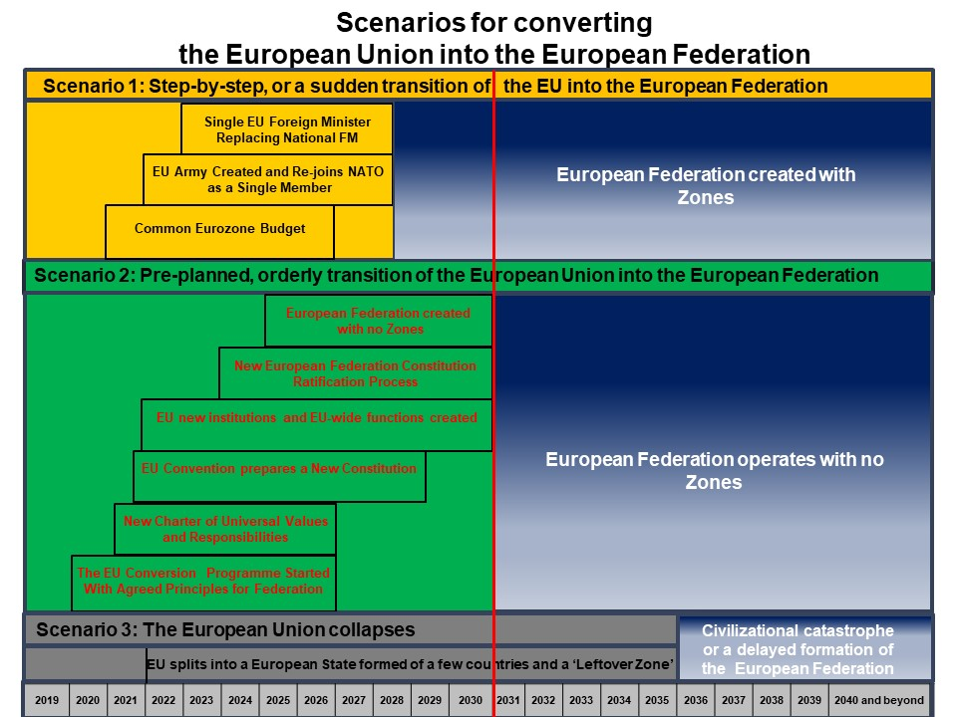
Tony Czarnecki: 'Democracy for a Human Federation', London 2019
- Quite sudden, unprepared transition to a rudimentary federation, when only the most necessary functions would be federated, such as defence, security, foreign affairs and the budget, while the remaining ones will be in a state of limbo or chaos.
- Making a transition in an orderly fashion, carried out in small steps, partly under disguise but ultimately leading to the implementation of an entirely new system of governance within the European Federation, when most of the current member states would join in.
- European Union collapses. The longer the federalization is put off the higher the risk that it may not happen at all, and the EU collapses or shrinks to a relatively small federated state. Should such an unexpected very serious event happen, the EU might be completely dissolved.

