Human Federation
Author | Tony Czarnecki
Date | 2020-01-17 06:12:25
Humanity has now entered a new period where global change happens at a nearly exponential, rather than a linear pace. This type of change is called exponential, because at each new moment in time (say every year), the value of what we measure (e.g. no. of electric cars or stem-cell originated meat production) would almost double. Ray Kurzweil, one of the most often quoted futurists, illustrates the difference between exponential and linear growth as follows: if we are standing together and I take 30 linear steps away from you, each 1m length, then I will be 30 meters away from you when I stop. But if I take 30 exponential steps away from you, then the first step will be 1m (equal to your first step), the second step will be 2m, the third step will be 4m, etc. So, by the time I have done my 30 steps, I will have gone around the earth 26 times. Today, the exponential growth of technology is starting to reach the so called “knee of curve”. This is the stage at which an exponential trend becomes noticeable. Shortly after this stage, the trend can really explode.
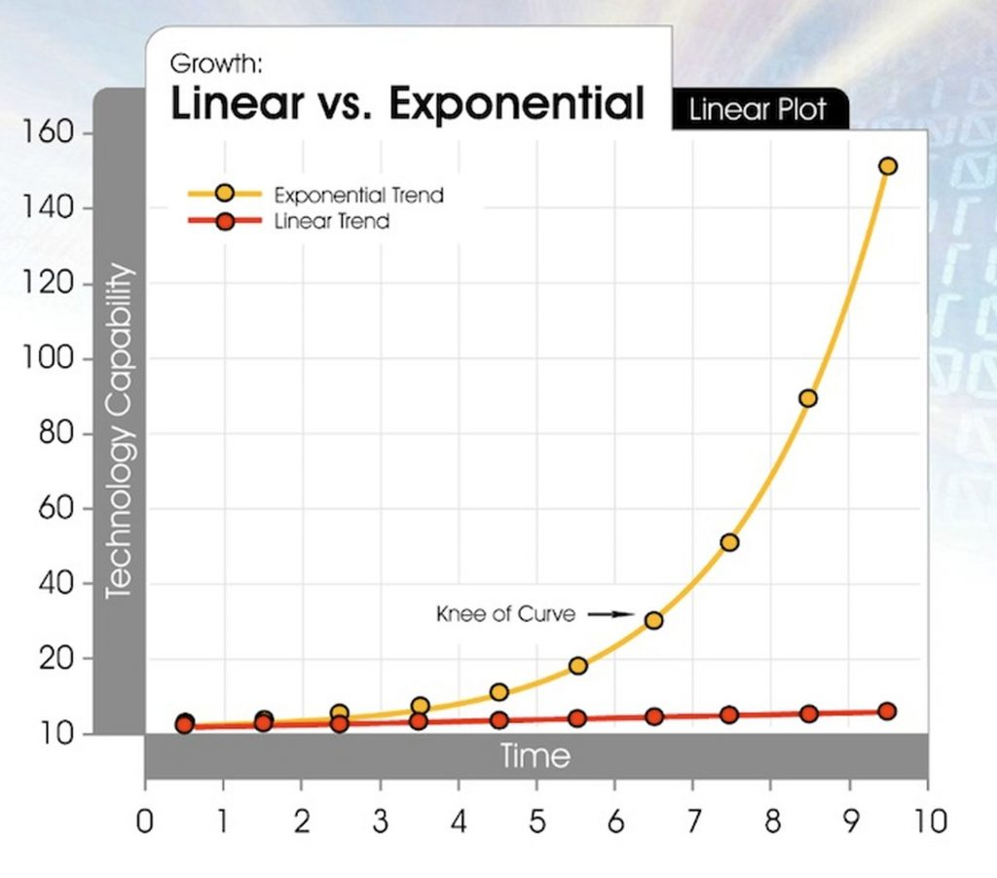
Source: “Singularity is Near” (Kurzweil, 2006)
Therefore, what today takes 1 year, in a decade it will take about 1 week, and in two decades about an hour. Such unprecedented exponential change may have either a positive or a negative impact on the long-term outcome for the human race. This largely depends on how we use the potential of such discoveries and innovation, i.e. Artificial Intelligence. That is the main subject of this website: how can we make safest possible transition to coexistence with the ultimate form of AI - Superintelligence.
I emphasize the fundamental role that a democratic system of governance must play in the several decades long transition period. It is through a deep reform of democracy that we can reset the relationship between the nations, based on Universal Values of Humanity, which best describe what it means to be a human being. These are the values, which should be inherited by Superintelligence. That is why democratic reforms must be anchored to some fundamental principles, such as those in the Consensual Presidential Democracy: Balanced Rights and Responsibilities, Political Consensus, Deep Decentralization and AI-assisted Governance.
But the reform of democracy must also lead to the creation of new institutions, which will ensure that at least man-made existential risks, such as the risk of developing a malicious Superintelligence, global warming or global disorder, are minimized. That is why the European Union has been identified as the most likely existing organization, which by transforming itself into the European Federation (EF) State could take the role of the de facto World Government and gradually evolve into the Human Federation (HF). This may happen by 2040 following one of the 5 scenarios I have developed and which are described in the subsequent tabs.

