Selecting the best candidate for a Human Federation
Author | Tony Czarnecki
Date | 2018-04-28 20:43:51
As mentioned earlier, there is at least 20% chance that one of the man-made existential risks will materialize by the end of this century, making our species extinct. However, some experts, like prof. Martin Rees, or the late Stephen Hawking, assess such a risk as at least 50%. If we are to survive, we need to apply a planet-wide risk mitigation strategy managed by a powerful planetary organization. We would need the World Government, which if it is to be effective, would have to be created by the end of this decade since both Superintelligence (immature) and Climate Change have a tipping point at about 2030.
But to create such a World Government from scratch by about 2030 is absolutely unrealistic. The only alternative might be to transform an existing organisation, whose scope and prerogatives must be greatly extended, into the World Government. To be successful in mitigating existential risks it should have a mandate from all of us to act on our behalf. That of course will not happen within such a short time. Would those who hold power in autocratic or dictatorial regimes give up their privileges and introduce a democratic World Government? Certainly not. This is perhaps one of the reasons why we are in such an existential danger. Therefore, the only plausible solution, is to assume that any supranational organisation, which is to be transformed into the World Government, will initially only include most democratic countries. The remaining ones would join much later, most likely under economic or technological pressure (e.g. inability to function in an entirely different world).
What organization or a state has the best credentials to become a de facto World Government? You may immediately ask – why shouldn’t the United Nations play such a role? My short reply would be – consider the latest example of the UN impotence to stop the war in Syria. But I would not like to dismiss the UN on just a singular evidence. We need to specify the scope and prerogatives needed for such an organisation to be successful in mitigating existential risks so that we can identify a credible candidate. Here is a check list of the required capabilities for playing the role of the World Government:
- Could the organisation execute supranational powers over a large part of the globe?
- Does it have, or will it soon have, its own army and rescue services?
- Will it be able to redefine human values that would become the foundation for the new constitution and a legal system underpinning the future Human Federation?
- Could it ensure a fast and co-ordinated response in emergency (potentially within hours)?
- Does it have a large reserve of emergency supplies of food, seeds, etc.?
- Does it have experience in dealing with large scale, global crises?
- Does it have long experience in democracy and the rule of law, so that any decisions are made according to democratic rules, acceptable to a majority of the population?
- Does it have enough resources, including financial, to deal with the current existential risks?
- Is it likely that it will be open to free and fair criticism and will it act on it?
- Will it be able to change the way it works and introduce new laws very rapidly?
- Does it have almost immediate access to best scientists and practitioners in every domain?
- Does it have, or will it be able to develop, an early warning system?
- Could it create a large refuge for millions of people (a physical space in case of a catastrophic danger, i.e. huge caverns, or tunnels)?
- Does it have and can it store large supplies of vaccines and medicines?
- Is it, or will it be, capable of reducing nuclear proliferation?
- Does it have or will it be capable of a strict oversight of molecular technologies?
- Will it be able to fight populism with facts?
Now, that we know what capabilities such an organisation must have to mitigate existential risks, how would we then select the best candidate to play the role of the World Government. To select such an organisation, I have created a table with 10 rather than 17 selection criteria for 10 organizations or large countries. I have tried to make the selection as objective as possible. 3 of the 10 criteria that I have used are completely objective: military power, territory size, and GDP. The remaining 7 criteria are subjective, but that subjectivity is within a narrow margin, which over the 10 criteria could not make a big difference (I give a comprehensive justification for the criteria and the weights in my latest book ‘Becoming a Butterfly’). The whole objective of this process is to select an organisation, which is likely to be one of the top three candidates, whatever the weights. The results are presented in the table below.
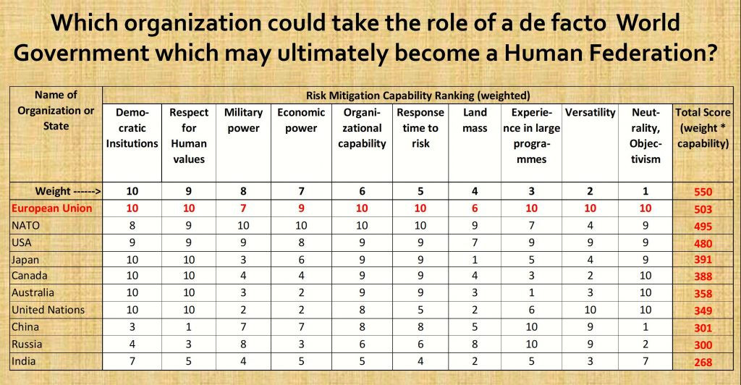
Which organization could become a de facto World Government?
As you can see, the organization that has come at the top is the European Union. It could be gradually transformed, initially including only perhaps 30-35 countries, from the current confederation status into a full Federation, in a similar manner to the Eurozone expansion. It is already planning to take on new members, so in the next 10 years we may have other countries such as Ukraine or Georgia as members of this re-invented organization.
Let me now make a few comments on some countries and the assigned values. As you can see there is not a big difference between the first three countries but there is a big difference between the third (USA and the fourth (Japan). So, I will only make comments on the first three countries for each of the categories.
- General remarks. If the scores are the same for an organization and a single country, then a country gets one point less because it is much more difficult to achieve a given rank, in an organization composed of many countries, than in a single country. Therefore, USA can get a maximum of 9 points.
- Democracy: NATO was scored lower because of Turkey (autocracy) and Albania, Bulgaria, Romania and Montenegro and Slovakia (all have too high level of corruption).
- Human rights. NATO was scored lower because of Turkey (autocracy).
- Military Power. EU’s military power score was the same as China’s (because China is a single state and gets 1 point less). USA, the strongest power was scored 9 points because as a single state it gets 1 point less than a maximum 10).
- Economic power. No adjustment made.
- Organizational capability. USA was scored 9 points because as a single state it gets 1 point less than an organisation.
- Response time to risk. USA was scored 9 points because as a single state it gets 1 point less than an organisation.
- Land Mass. No adjustment made.
- Experience in large programmes. USA was scored 9 points because as a single state it gets 1 point less than an organisation. NATO adjustment is due to experience in mainly military operations.
- Versatility. USA was scored 9 points because as a single state it gets 1 point less than an organisation. NATO adjustment is again due to lack of versatility and focus on military operations only. That however may change in the future.
- Neutrality and objectivism. USA was scored 9 points because as a single state it gets 1 point less than an organisation. NATO adjustment is due to Turkey’s operations in Syria and Iraq and the autocracy of that regime.
If NATO takes up this role, it will have to expand significantly its scope but it lacks sufficient experience. However, when the European Federation is set up and the European Army becomes part of NATO as a whole, merging the two organizations completely is a very logical and perhaps almost a natural step forward.
As far as the USA is concerned, the main obstacle here are the American voters. They are unlikely to agree to constrain their personal and national freedom and see the USA as just one of the nations within such a federation. It is enough to mention the futility of imposing any sensible gun control in the USA, to see that this option is rather unlikely.
Finally, it is quite possible that none of these options will bear fruit by about 2030. In such case, my default alternative would be China. Just consider that every sixth person on the planet is a Chinese. But are most humans ready to pass control to the next species based on Chinese values alone? It is a challenging thought that deserves a detailed and impartial analysis, which is beyond the scope of this article.
In the end, even if NATO or the USA had been chosen instead of the European Union, the whole process of changes that would have to be applied to any of these three organisations would have been similar. However, the changes to be applied to convert NATO or even more so, the USA, into a de facto World Government would have been much more difficult. In any case, I consider the EU as a kind of a strawman to see what kind of organizational and political changes the candidate for the potential World Government would have to go through. That does not mean that it will happen. I am only suggesting what would be the best choice for a human race at this stage of our civilizational evolution.
Additionally, let’s remind ourselves that the key question is, which organisation is potentially the best one to control the risk stemming from AI when it achieves the status of Superintelligence and ultimately becomes a Technological Singularity. Additionally, Superintelligence is only one of the existential risks that need to be mitigated. Therefore, any organisation that we choose to act on behalf of the whole Humanity must be capable of dealing with other risks too, including the Global Political and Social risks. The EU seems to fulfil these conditions best.
Let us now look more closely at the EU’s capabilities, its strengths and weaknesses and the scope of reforming the EU so that it could start acting as a de facto World Government. In general, the EU has quite a few features that are important for that task, such as:
- Nearly uniform human values and legal system
- A wide spectrum of activities comparable with the UN
- A lot of experience in large international projects, like the accession of 10 eastern and central European countries on 1.5.2004.
- Significant financial and material resources
- A system extending beyond a typical confederation, with the president (President of the Council of Ministers), the Government (the EU Commission), the prime-minister (the President of the EU Commission) and the Parliament (the European Union Parliament)
- Dynamism. What may surprise some people, is that there are very few other large organisations in the world that are as dynamic as the EU. Over the last 60 years the EU has been continuously adding new members, significantly changing the way in which it operates and continually distributing resources to poorer members on a large scale
- Ability to expand rapidly by integrating more countries, which are themselves significant global powers, such as Canada, Australia, and Japan, with which the EU has already signed wide-ranging treaties.
When in 2010 the European Commission conducted a poll on whether the people questioned think they have the EU citizenship identity, 62 per cent of the respondents said they already felt like EU citizens. In August 2017, 68 per cent of the population (33,000 people surveyed across the EU) felt “they are a citizen of the EU”. 56% of people across the continent were optimistic about the future of the EU in general – a rise in six points on the previous survey published in the autumn of 2016.
If life rejuvenation is successful, then most of you will see the first day of the 22nd century. But to arrive there, we need to go through a stage of transition. We need to begin the process of federalization of the Planet. And that should start with the federalization of the EU.
When in 2010 the European Commission conducted a poll on whether the people questioned think they have the EU citizenship identity, 62 per cent of the respondents said they already felt like EU citizens (Politico). In August 2017, 68 per cent of the population (33,000 people surveyed across the EU) felt “they are a citizen of the EU”. 56% of people across the continent were optimistic about the future of the EU in general – a rise in six points on the previous survey published in the autumn of 2016 (Stone, 2017).
So, why are people in the EU so optimistic barely a year after a bad experience with massive migration? Partially the sharp rise in optimism could be linked to the elections in the Netherlands and presidential elections in France, where Emmanuel Macron saw off a far-right challenger Marie Le Pen. The other factor could be the end of austerity in Portugal and the kick-start of the growth investment programme in the Southern European countries. But there are other less direct reasons to justify such a cautious optimism and they lie rather in the political than economic domain, like putting some structural reforms to managing the EU borders (Frontex agency) and moves towards closer integration sparked off by Brexit.
IIf life rejuvenation is successful, then most of the people living today will see the first day of the 22nd century. But to arrive there, we need to go through a stage of transition. We need to begin the process of federalization of the Planet. And that should start with the federalization of the EU.

