4. Federate to Survive
Author | Tony Czarnecki
Date | 2018-04-26 11:36:42
Anyone that wants to improve the situation and reduce some of the existential risks faces three problems:
- Existential risks require fast action, while the world’s organisations act very slowly
- People want more freedom, while we need to sacrifice some of our freedoms and sovereignty for Humanity to survive
- Most people can’t see beyond tomorrow and act emotionally, while we need to act rationally and see the long-term consequences of our actions.
Therefore, anybody that sees the need for the world to take an urgent action faces a difficult task when proposing pragmatic, fast and very radical changes to the way the world is governed. It seems to me that the only realistic route for humans to take is to create a new organisation, which would have the capacity, resources and resolve to act on behalf of all of us in the hour of the emerging existential threat. To have any chance of successful delivery of its foremost objective, i.e. to protect Humanity against existential risks, such an organisation should have supranational powers exceeding any prerogatives of the existing international bodies, such as the United Nations, NATO or WTO. We need an organization that would resemble the World Government. Only such an organisation, which should be operational latest by about 2030, would have some chance to mitigate not just global political and social risks but all other existential risks mentioned earlier.
The agenda of such an organisation should be governed by one key issue: Fighting existential risks. Any other objectives are subordinate to that goal, since if there is no Humanity and no civilisation there is no point to discuss other aims of such an organisation. 2030 is a threshold date, because by then we must have a full control mechanism over AI in place (see here). This objective is the driver for the entire scope of this website.
This chart shows the main areas that need to be fundamentally changed because of the threat from Superintelligence and other existential risks, culminating in creating a supranational governing organization that will lead us all through that perilous period.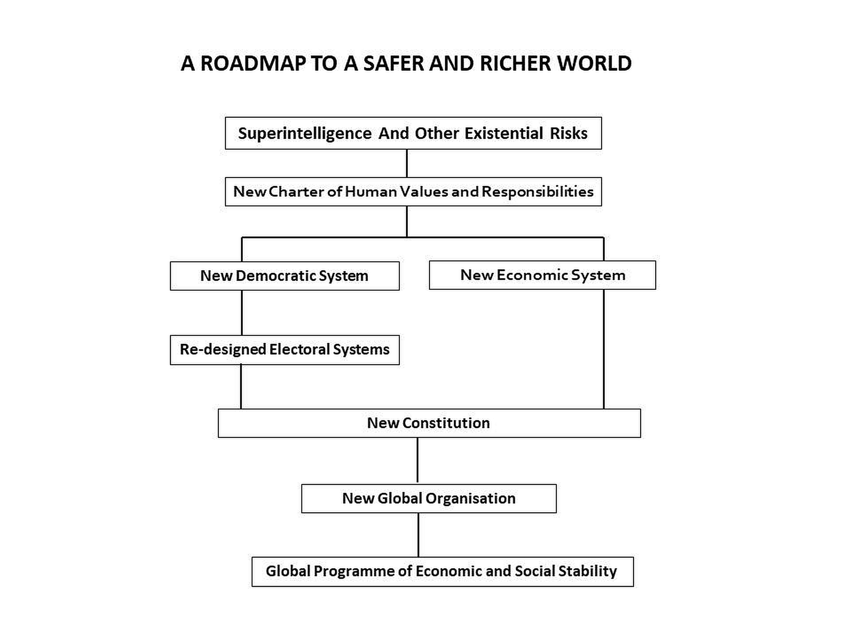
Now, the question is who could do it? What we are discussing here is how to guide Humanity and protect our civilisation in the next 20 years, while it passes through probably the most dangerous period in its history. By then Humanity could reach the point when it may already be coexisting with Superintelligence, which would hopefully act in unison with us, helping to sort out our problems.
We are already late in creating such a large supranational organisation. Perhaps one of the reasons is that many of us still hope for the UN to take up such a role, or that the UN itself will be quickly transformed into such an organisation. After all, this is the organisation that should deal with existential risks in the first place. Unfortunately, this is also the organisation that indirectly increases the Humanity’s overall existential risk by being almost totally ineffective in solving grave problems. UN may be trying to apply some solutions but quite often when it is too late, or a grave human, economic and ecological danger has already been done. In most cases it is just incapable of solving the problems at all (e.g. Syria or Libya). The best evidence in my view is the creation by the UN of the International Strategy for Disaster Reduction (UNISDR) the organization that was established in 1999. It has had hardly any influence on any of the top existential risks listed earlier. The only real impact that the UN has, considering its actual impact on legislation is the health area, especially the control of pandemics by WHO - probably the most effective UN agency and to some extent climate change by its otehr agency - the International Panel on Climate Change (IPCC). The reason behind that is simple. Such an organisation to act successfully would have needed the powers far superior than the UN has now. Since we know how embarrassingly ineffective the UN has been, no wonder that the world is practically left to be gradually sucked into the funnel of ever growing existential risks. Initially this will be hardly visible but further into the future the risks will tend to combine. At that time there may be no organisation or a country powerful enough to stop the demise of our civilisation.
Transforming the UN into the World Government is also a futile hope, because of the very way the UN makes decisions – the unanimity voting in the Security Council. The presence of the unanimity voting for most decisions made by the European Council is the same reason why the EU has been less effective than it could have been. Fortunately, the Lisbon Treaty has finally created a possibility for the European Council to vote using a qualified majority on more subject domains than ever before.
Since the existential risks can materialize at any time, e.g. natural pandemics like the Coronavirus pandemics in 2020 or due to laboratory-generated bugs being maliciously released in the open, we should have an organization that could act as de facto World Government right now. I have already indicated earlier on, that creating the World Government from scratch at such a short time, is not feasible. Therefore, the only way that could happen, is by transforming an existing organisation, or empower a single large country with supranational powers, into the World Government. That new global organisation would gradually substitute the UN, based on a fundamental review of human values.

Comments

Tony Czarnecki
Thank you, Ian, for your valuable comments and your input at my book launch. You beat me by 46 years with your 'The Spring of Civilization' book. Yes, for me deep decentralization of the future Human Federation, following the principles, of the Minimalist State, is the key to the creation of the Human Federation. In my view, and here we may differ a bit, we simply have no time left to wait for all the nations to agree to one common Constitution of Humanity, such as porposed by the World Federalist Movement and similar organizations. We must act right now and get the majority of the countries to agree to become members of an existing organization, which has the best chance to act on behalf of us all. A significantly reformed European Union, transformed into the European Federation, seems to be the most likely organisation that could quickly achieve the status of a de facto World Government and later on, by simply having a critical mass, become the Human Federation.

Ian Hackett
I've just enjoyed Democracy For A Human Federation purchased at last month's Federal Trust event, particularly the idea of deep decentralization as key to a viable world federation, which reminded me of the idea of "a thousand eutopias" described in my book, The Spring of Civilization (1973); and that of the EU evolving into a world federation, an option I considered in my Succeeding Revolutions (2006). I was also impressed by the bibliography, but noted the absence of several key works. Apart from the above, I would recommend George Monbiot: The Age of Consent; Rutger Bregman: Utopia for Realists; and Jo Leinem & Andreas Bummel: A World Parliament. All of these books contain ideas that would complement those of Tony Czarnecki.

